Test Case: tc002_SPX_Dev5_Crear_Requisicion_Spot_Con_FAD_Tipo_Cobro_CC
Step 1 - Enter username and password and click to button Enter : Credentials Entered
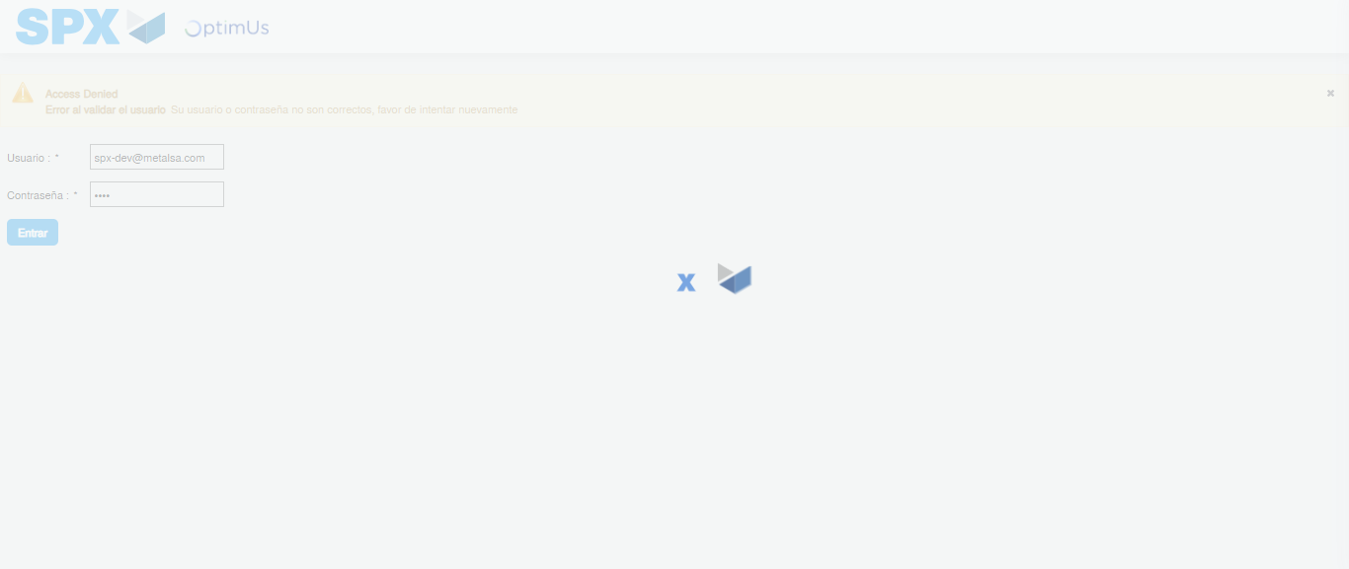Image file-name: QC_Testing-tc002_SPX_Dev5_Crear_Requisicion_Spot_Con_FAD_Tipo_Cobro_CC-1783354285128

Step 2 - Select to UEN and Access to Spot Buy Requisitions : UEN Correctly selected and Correct access
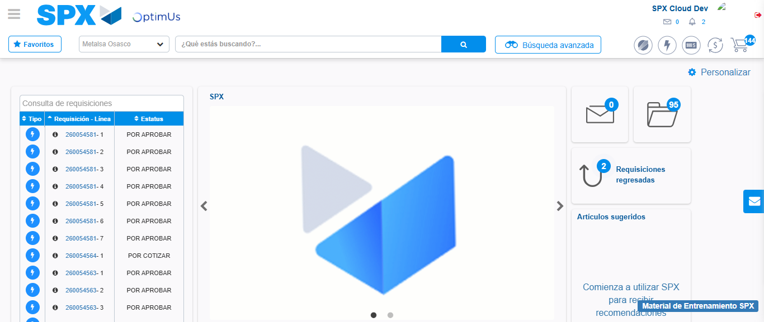Image file-name: QC_Testing-tc002_SPX_Dev5_Crear_Requisicion_Spot_Con_FAD_Tipo_Cobro_CC-1783354310296

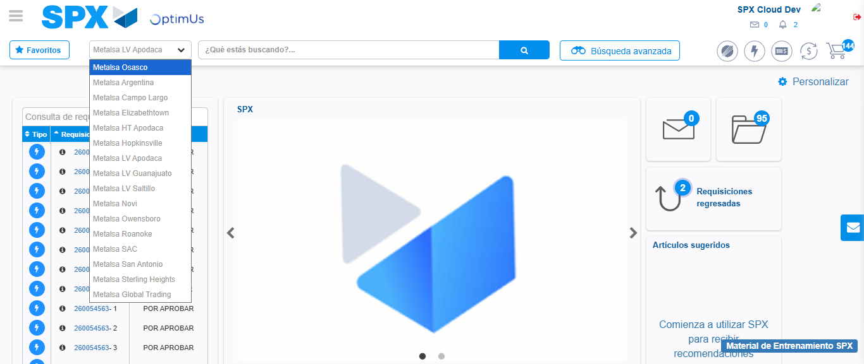Image file-name: QC_Testing-tc002_SPX_Dev5_Crear_Requisicion_Spot_Con_FAD_Tipo_Cobro_CC-1783354312901

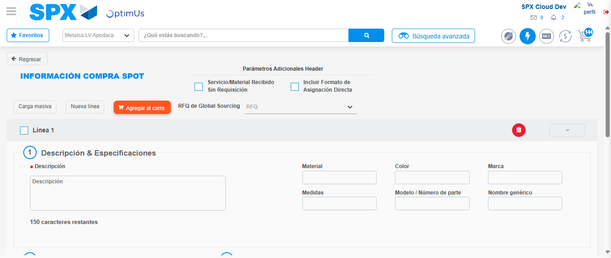Image file-name: QC_Testing-tc002_SPX_Dev5_Crear_Requisicion_Spot_Con_FAD_Tipo_Cobro_CC-1783354334161

Step 3 - Add FAD to Requisition: FAD Successfully Added
Image file-name: QC_Testing-tc002_SPX_Dev5_Crear_Requisicion_Spot_Con_FAD_Tipo_Cobro_CC-1783354334400

Image file-name: QC_Testing-tc002_SPX_Dev5_Crear_Requisicion_Spot_Con_FAD_Tipo_Cobro_CC-1783354334554

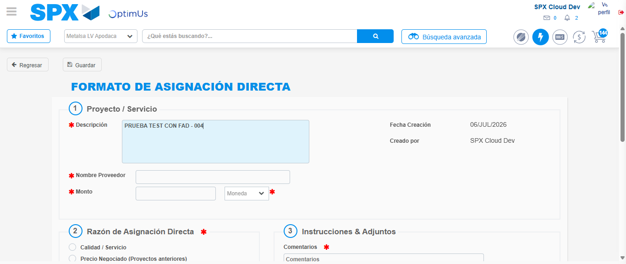Image file-name: QC_Testing-tc002_SPX_Dev5_Crear_Requisicion_Spot_Con_FAD_Tipo_Cobro_CC-1783354337266

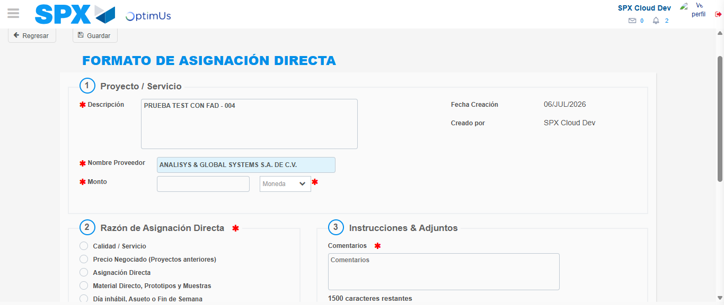Image file-name: QC_Testing-tc002_SPX_Dev5_Crear_Requisicion_Spot_Con_FAD_Tipo_Cobro_CC-1783354343151

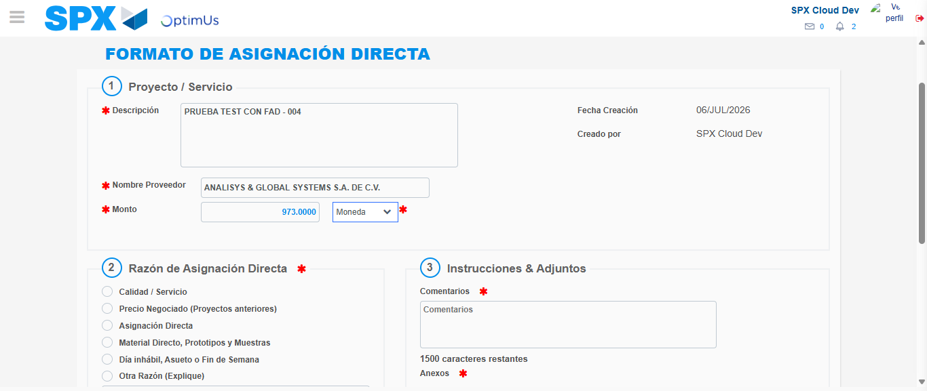Image file-name: QC_Testing-tc002_SPX_Dev5_Crear_Requisicion_Spot_Con_FAD_Tipo_Cobro_CC-1783354343626

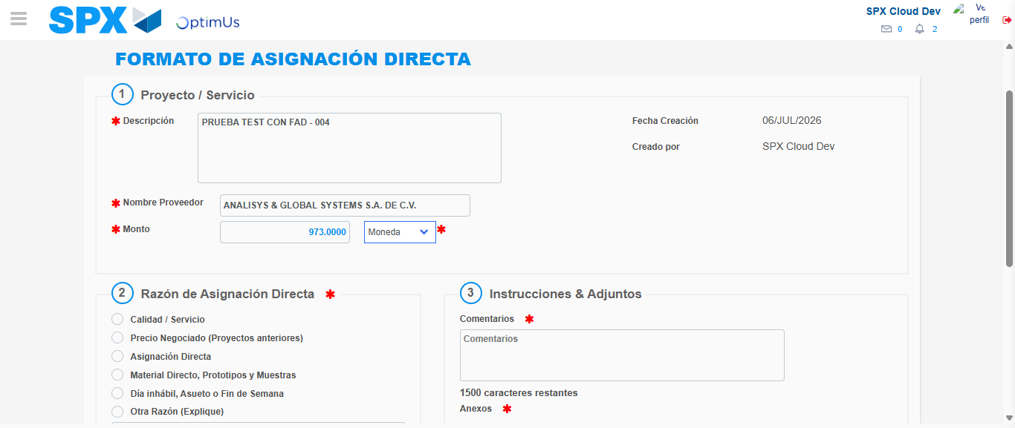Image file-name: QC_Testing-tc002_SPX_Dev5_Crear_Requisicion_Spot_Con_FAD_Tipo_Cobro_CC-1783354343843

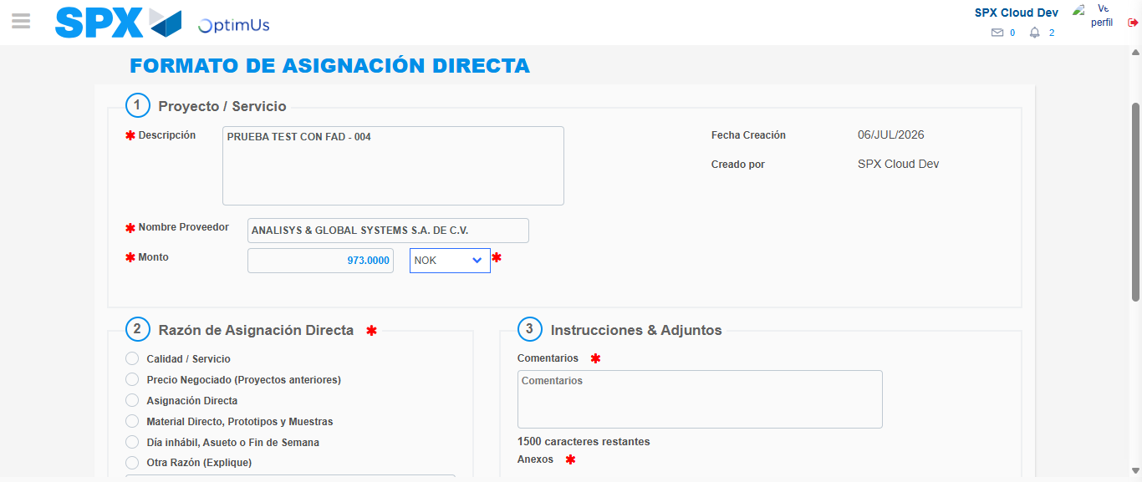Image file-name: QC_Testing-tc002_SPX_Dev5_Crear_Requisicion_Spot_Con_FAD_Tipo_Cobro_CC-1783354344200

Image file-name: QC_Testing-tc002_SPX_Dev5_Crear_Requisicion_Spot_Con_FAD_Tipo_Cobro_CC-1783354344402

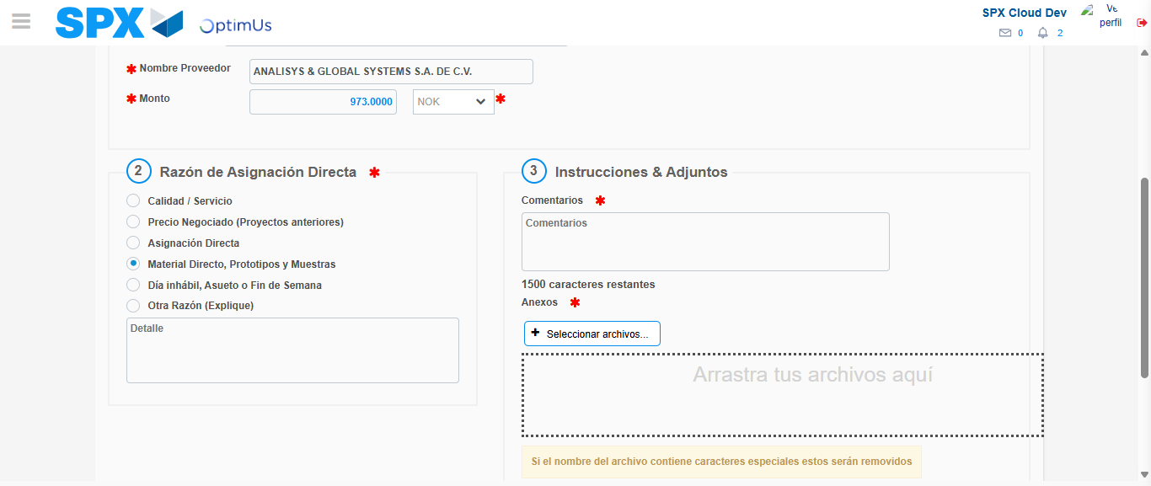Image file-name: QC_Testing-tc002_SPX_Dev5_Crear_Requisicion_Spot_Con_FAD_Tipo_Cobro_CC-1783354345228

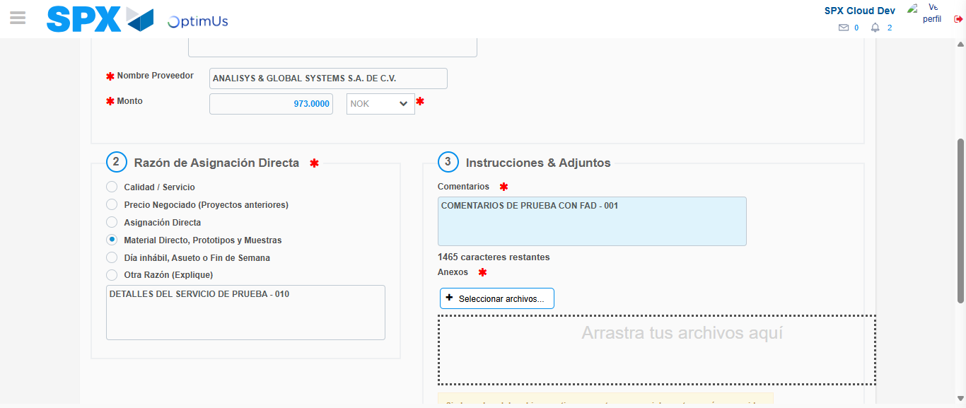Image file-name: QC_Testing-tc002_SPX_Dev5_Crear_Requisicion_Spot_Con_FAD_Tipo_Cobro_CC-1783354356199

Image file-name: QC_Testing-tc002_SPX_Dev5_Crear_Requisicion_Spot_Con_FAD_Tipo_Cobro_CC-1783354357004

Step 4 - Data Capture Spot Buy Requisition: Data captured correctly
Image file-name: QC_Testing-tc002_SPX_Dev5_Crear_Requisicion_Spot_Con_FAD_Tipo_Cobro_CC-1783354334400

Image file-name: QC_Testing-tc002_SPX_Dev5_Crear_Requisicion_Spot_Con_FAD_Tipo_Cobro_CC-1783354334554

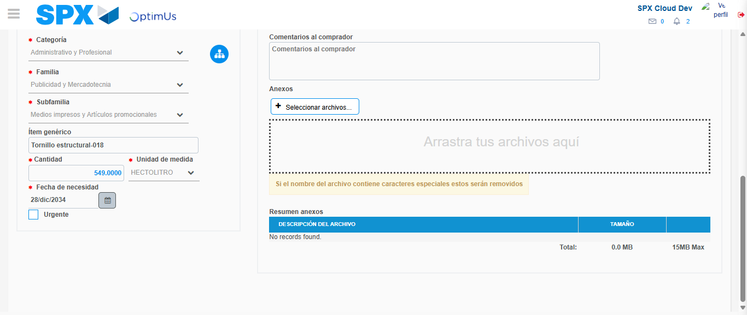Image file-name: QC_Testing-tc002_SPX_Dev5_Crear_Requisicion_Spot_Con_FAD_Tipo_Cobro_CC-1783354369159

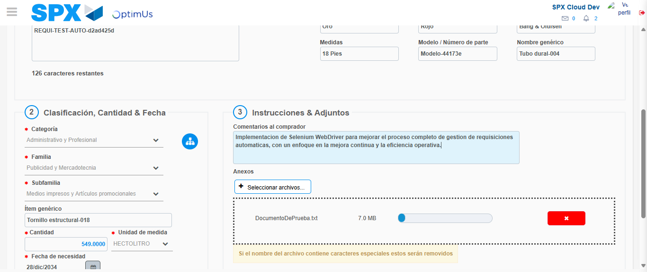Image file-name: QC_Testing-tc002_SPX_Dev5_Crear_Requisicion_Spot_Con_FAD_Tipo_Cobro_CC-1783354369874

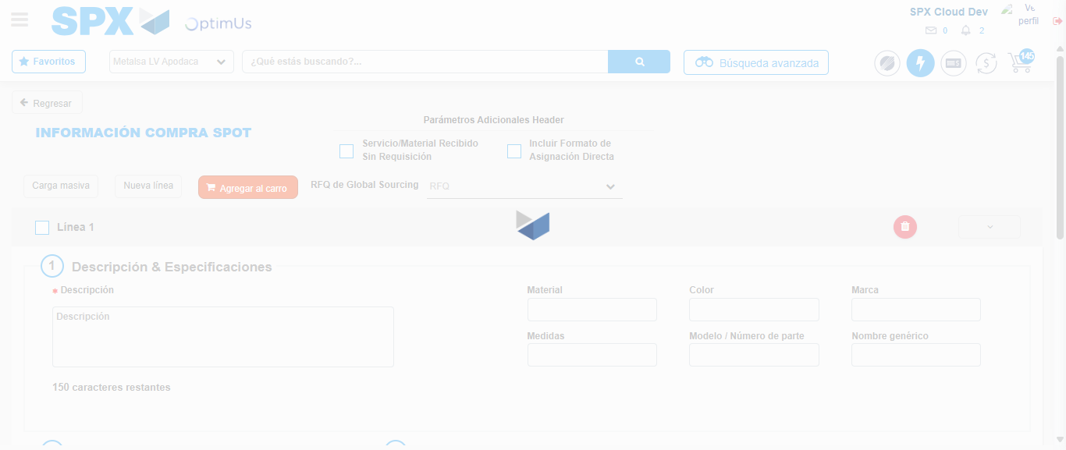Image file-name: QC_Testing-tc002_SPX_Dev5_Crear_Requisicion_Spot_Con_FAD_Tipo_Cobro_CC-1783354380084

Step 8 - Return to Main Page SPX : Return to Main Page SPX
Image file-name: QC_Testing-tc002_SPX_Dev5_Crear_Requisicion_Spot_Con_FAD_Tipo_Cobro_CC-1783354310296

Image file-name: QC_Testing-tc002_SPX_Dev5_Crear_Requisicion_Spot_Con_FAD_Tipo_Cobro_CC-1783354312901

Image file-name: QC_Testing-tc002_SPX_Dev5_Crear_Requisicion_Spot_Con_FAD_Tipo_Cobro_CC-1783354334161

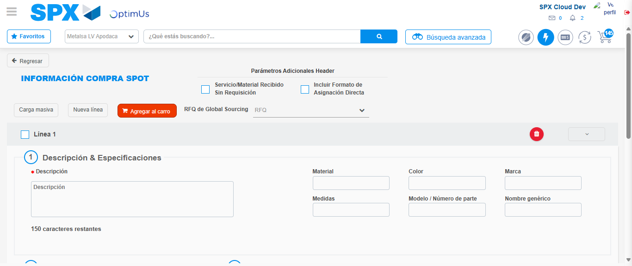Image file-name: QC_Testing-tc002_SPX_Dev5_Crear_Requisicion_Spot_Con_FAD_Tipo_Cobro_CC-1783354382381

Image file-name: QC_Testing-tc002_SPX_Dev5_Crear_Requisicion_Spot_Con_FAD_Tipo_Cobro_CC-1783354382541

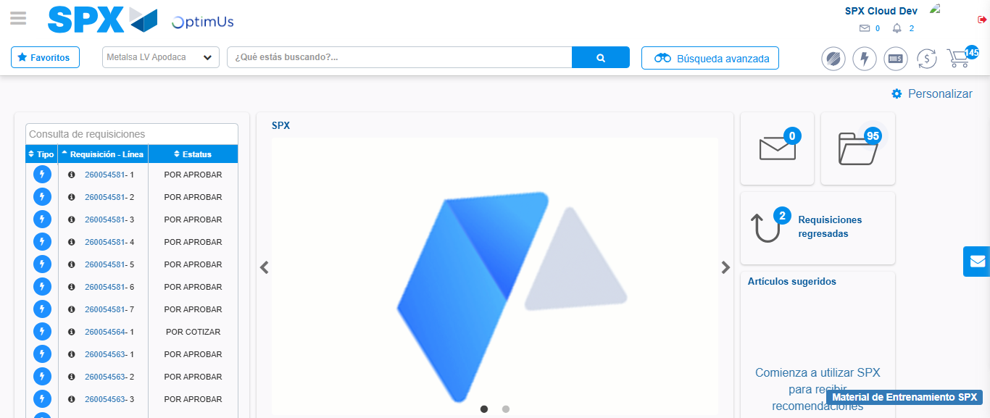Image file-name: QC_Testing-tc002_SPX_Dev5_Crear_Requisicion_Spot_Con_FAD_Tipo_Cobro_CC-1783354403590

Step 9 - Log Out : Log Out SPX
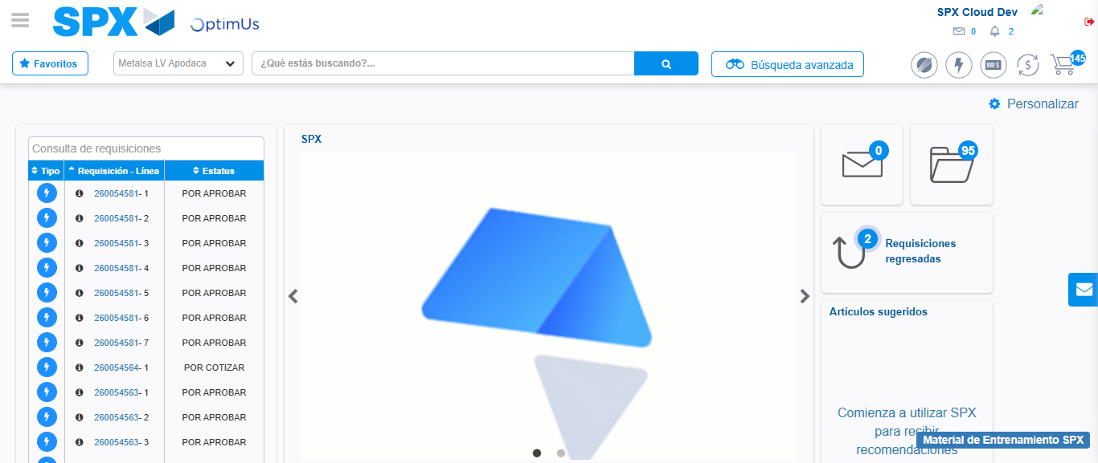Image file-name: QC_Testing-tc002_SPX_Dev5_Crear_Requisicion_Spot_Con_FAD_Tipo_Cobro_CC-1783354404067

